ENSF 594 YYC Project Research

# Phase I

Erfan’s suggestion on fast development:

“

*Coding this segment should take 2-3 days maximum*

*Bright mindset in coding means developing coding asap*

*First thing you need to know is that you don’t need to know that much about big words like GUI database mapping.*

*They are just concepts I want you to implement, you don’t need to know how it works. Think of it in the abstract, see it as a package you can communicate with. Who cares about the details of the database, the question is can you communicate with the database*

*You should only need 5 line of code to communicate with database.*

*To be a good developer you need to understand that you don’t need to know everything. An intel developer said that if it takes more than 3 months to prototype a project, then it is a failure. Knowing everything in detail may not be the path to succeeding.*

*Don’t look at the details, look at it as abstract, big picture.*

“

When doing you code you should:

“ *Imagine that you are selling your project. This is the mindset that you should present yourself in*”

1. Include who wrote the code
2. Reference websites or documents that you used
3. The Licenses that you used.
4. When you present your coding
   1. Explain how you planned it
   2. How you implement it
   3. Concerns about your packages

## Packages

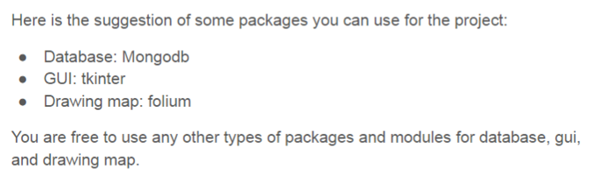

## Database

This link tells you how to use mongodb with python:

<https://www.w3schools.com/python/python_mongodb_getstarted.asp>

This is the mongodb website:

<https://www.mongodb.com/>

Link below is reference material as suggested by Erfan:

<https://www.mongodb.com/blog/post/getting-started-with-python-and-mongodb>

## GUI

GUI can be developed using tkinter.

Erfan Suggestion:

“

*This is like Jframe, but you use TK module.*

*You start with the TK object that gives you the window and label.*

“

Refer to this link:

<https://realpython.com/python-gui-tkinter/>

## Drawing Map

For mapping, use Leaflet, it uses Java script.

Folium is the wrap around for leaflet so you can use python.

<https://python-visualization.github.io/folium/>